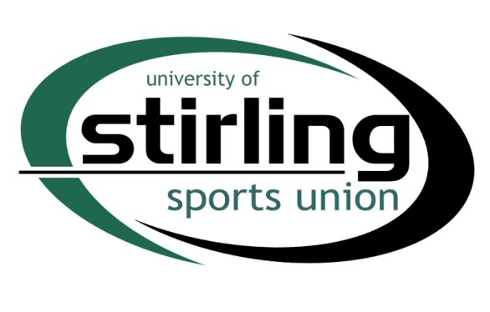
DEVELOPMENT FUND APPLICATION

A Development Fund Application must be typed,
emailed to sports.union@stir.ac.uk and should meet the
following criteria:
- The application must be at least 150 words to be considered,
- The course must be used for a minimum of 1 year,
- The course should be essential for the growth and development of the club,
- The course should be booked through the Sports Union,
- The Sports Union will look at Development Funds allocations on a match funding basis
- If successful, the Club will have 3 months to spend the awarded amount.

CLUB:

NAME OF APPLICANT AND CLUB:

CURRENT COACHING/OFFICIATING QUALIFICATION:

EXPERIENCE (MIN 150 WORDS):

NAME OF COURSE:

UKCC LEVEL:

AMOUNT CLUB WILL CONTRIBUTE:
AMOUNT CLUB APPLYING FOR:

WHY IS THIS COURSE ESSENTIAL FOR GROWTH/DEVELOPMENT? (MIN 150 WORDS):

Signed: ___________________ Name: _________________________
Date: ___________________ Position in club: _________________________

