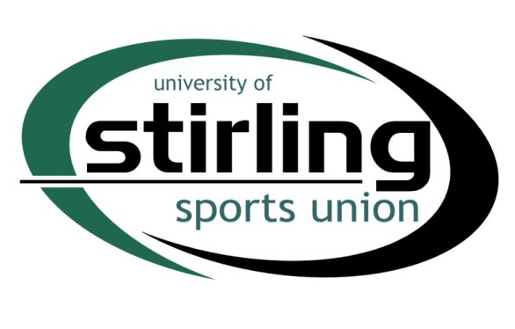
CAPITAL EQUIPMENT FUND APPLICATION

A Capital Equipment Application must be typed, emailed to sports.union@stir.ac.uk and should meet the following criteria:
- The application must be at least 150 words to be considered,
- The equipment must last a minimum of 3 years,
- The equipment should be essential for the growth and development of the club,
- The equipment should not consist of balls/cones/bibs etc.
- The Sports Union will look at Capital Equipment Funds allocations on a match funding basis
- If successful, the Club will have 3 months to spend the awarded amount.

CLUB:

ITEM OF EQUIPMENT TO BE PURCHASED:

COST OF EQUIPMENT:

AMOUNT CLUB WILL CONTRIBUTE:

AMOUNT CLUB APPLYING FOR:

WHY IS THIS EQUIPMENT ESSENTIAL FOR GROWTH/DEVELOPMENT? (MIN 150 WORDS):

Signed: ___________________ Name: ______________________________
Date: ___________________ Position in club: ______________________________

