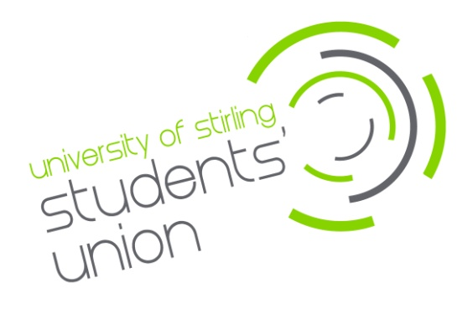

Recruitment
Faculty Officer (Undergraduate)

£10.90 per hour (90 hours per year)
The University of Stirling Students’ Union is offering an exciting opportunity to join our staff team. We are looking for confident and enthusiastic people to provide student representation at a Faculty and University level, offer strategic input within academic faculties and to the University. You will play a key coordinating and support role within the module and programme representative network whilst delivering our vision to “Make Students Lives Better”.
Main duties will include:
- Contribute to and engage with the Module Representatives Canvas Training module; including the awarding of accreditation badges to UG representatives within your Division.
- Work with the designated staff within your Faculty to enhance learning, teaching and the student experience.
- Coordinate regular meetings with Module and Programme Representatives to gather student opinion on strategic issues.
- Oversee the work of Module and Programme Representatives within your division, helping foster communication and escalation of any recurring issues to the appropriate person.
- Actively promote and engage with Union activities in Learning & Teaching (such as the RATE Awards).
- Promote mechanisms to improve Learning and Teaching (such as the National Student Survey, Postgraduate Taught Experience Survey or Postgraduate Research Experience Survey).
- Undertake appropriate faculty projects to strategically improve the learning and student experience.
- When necessary, Faculty Officers will be asked to take part in a Learning and Teaching Review for academic Faculties/Divisions. One officer from out with the Faculty/Division being reviewed will be required for the one day event.

The hours for this post will be 90 per annum. The role will run from September 2023 to end of May 2024 (in line with the academic year). We have vacancies within the following divisions: Law and Philosophy; ITE (Primary); Accounting and Finance.

You must be a student of the division for which you are applying.

Closing date for applications is Monday 9th October 2023 (9am - GMT).
Interviews will be held Tuesday 17th October 2023.

For more details or to apply for the position please go to www.stirlingstudentsunion.com/recruitment.



