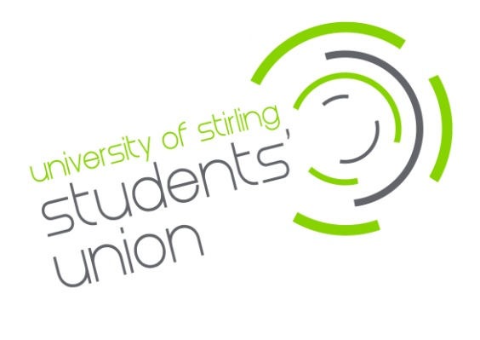

Recruitment
Undergraduate Division Officer

£12.00 per hour (90 hours per year)
The University of Stirling Students’ Union is offering an exciting opportunity to join our Division and Faculty Officer team. We are looking for confident and enthusiastic people to provide student representation at a Division and Faculty level, offering strategic input within academic divisions/faculties and to the University. You will be the lead Student Representative within your Division and you will play a key coordinating and support role within the academic representative network whilst also working with the Union and University to improve learning and teaching as well as the wider student experience.
Main duties will include:
- Attend all training and relevant meetings, including Feedback Forums, Learning and Teaching Committees, Education Zones and General Meetings.
- Collaborate with the designated staff within your Division and Faculty to enhance learning, teaching and the student experience.
- Support and engage with the Union’s Academic Representative Training
- Coordinate regular meetings with Academic Representatives to gather student opinion on strategic issues.
- Oversee the work of Academic Representatives within your division, helping foster communication and escalation of any recurring issues to the appropriate person.
- Actively promote and engage with Union activities in Learning & Teaching (such as the RATE Awards).
- Promote mechanisms to improve Learning and Teaching (such as the National Student Survey, Postgraduate Taught Experience Survey or Postgraduate Research Experience Survey).
- Undertake appropriate division and faculty projects to strategically improve the learning and student experience and develop at least one student-led event during your time in post.
- When necessary, Division and Faculty Officers will be asked to participate as Student Reviewers in Learning and Teaching Reviews for academic Faculties/Divisions.

The hours for this post will be 90 per annum. The role will start beginning of August 2024 and will run to the end of May 2025.

You must be a student of the division for which you are applying.

Closing date for applications is Thursday 9th May 2024 (9am - GMT).
Interviews will be held week commencing 20th May 2024.

For more details or to apply for the position please go to www.stirlingstudentsunion.com/recruitment.

