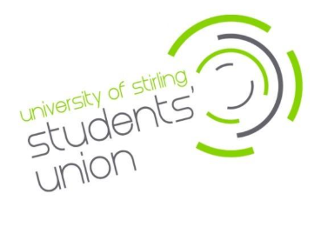

Job Advert
Harm Reduction Intern
£12.60 per hour (260 hours per year)
This is an externally funded post made possible with the You’re Only Young Once grant from the Corra Foundation. The fund has been designed by young people to provide support for children, young people and families affected by drugs and alcohol.
The Harm Reduction Intern will lead and co-design harm reduction campaigns and initiatives within Stirling Students’ Union. The intern will work closely with SU staff, external partners, and a newly established Student Harm Reduction Action Group to embed harm reduction strategies across campus.
Main duties will include:
- Co-design and deliver harm reduction campaigns.
- Recruit and coordinate a Student Harm Reduction Action Group.
- Organise training with partners like Crew Scotland and NHS Forth Valley.
- Support harm reduction events and distribute safety resources.

The hours for this post will be 260 per annum. The role will start as soon as possible and will run until December 2026.
You must be a registered Stirling University student at the time of application.
Closing date for applications is Tuesday 20th January 2026 (9am – GMT)
Interviews will be held on Friday 30th January 2026
For more details, please email ines.coutinho@stir.ac.uk
To apply for the position please email your application form to ines.coutinho@stir.ac.uk and equality monitoring form to wendy.forbes@stir.ac.uk.

