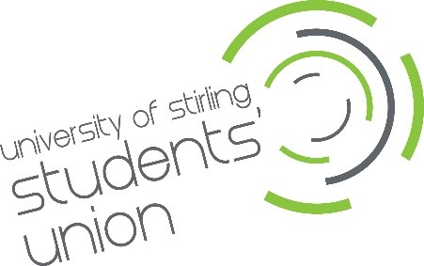
Green & Blue Space Hub Assistant

University of Stirling Students’ Union - Application Form

Your details

Full Name:

Address:

Postcode:

Student Number:

Year of Study:

Phone:

Email:

Please note: You must be an enrolled student at Stirling University for the full academic year 2026/27 (September 2026 to April 2027).

Application Guidance: While the word counts are upper limits rather than minimum requirements, the best applications tend to be the ones that go into detail in each question and provide specific examples.

Previous experience
Please tell us about your previous experience in a customer service or retail role, provide an example that you are particularly proud of, what skills did you use and what did you learn about yourself (up to 250 words).

Sustainability, circular economy, or community-based environmental projects
Please tell us what experience you have, professional or personal, of sustainability, circular economy or community-based environmental initiatives that you have been involved in (up to 250 words).

Supporting statement
Please tell us why you applied for the G&B Space Assistant role and why you think you are the best person for the job.

Interview arrangements and availability
Please tell us if there are any reasonable adjustments we can make to help you with your application.

Interviews will be held on Thursday 21st May 2026, no alternative dates are available. Interviews can be in person or via MS Teams.

Declaration
I confirm that to the best of my knowledge the information I have provided on this form is correct and I accept that providing deliberately false information could result in my dismissal.

Name:

Signature:

Date:

