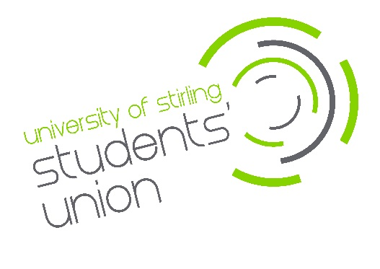
Consumer Data

Privacy Statement

Introduction
University of Stirling Students’ Union (“we”, “our” or “us”) promises to respect any personal data you share with us, or that we get from other organisations and keep it safe. We aim to be clear when we collect your data and not do anything you wouldn’t reasonably expect.

Facilitating our legal requirements, organisation policy and services to our customers (consumers) through using your personal data allows us to make better decisions, communicate more efficiently and, ultimately, ensure you receive the services required.

Legal Basis
We fulfil our legal obligations for storing and processing personal information in the following ways:
• Contract – for example, for the employment of staff.
• Legal obligation – We operate a data sharing agreement with the University of Stirling to comply with our combined legal obligation to provide a Students’ Union. This allows students to automatically sign in and use the Union’s website for information and for activities such as voting in Union elections and purchasing club memberships.
• Legitimate interests – in seeking to enhance the student experience at Stirling, we believe it is in your interest for us to provide administration in support of your membership of clubs and societies/Sports clubs, as elected representatives and much more. In respect of purchases and for liaison with suppliers, we similarly process data for legitimate purposes.
Further information is available by contacting theunion@stir.ac.uk

Where we collect information about you from
To place an order with us online, registration is required (if you are a registered student, please refer to our Student Data Privacy statement for more information as no separate registration is required). At the point of registration, we request certain information which is required to enable us to process your order and notify you of its progress.

When we collect it as you use our WEBSITES
Like most websites, we use “cookies” to help us make our site – and the way you use it – better. Cookies mean that a website will remember you. They’re small text files that sites transfer to your computer (or phone or tablet). They make interacting with a website faster and easier – for example by automatically filling your name and address in text fields. To find out more at cookies and how we use them, visit: https://www.stirlingstudentsunion.com/privacy/.
In addition, the type of device you’re using to access our website and the settings on that device may provide us with information about your device, including what type of device it is, what specific device you have and what operating system you’re using. Your device manufacturer or operating system provider will have more details about what information your device makes available to us.
When you BUY A PRODUCT from us
We collect information to enable us to process your order and notify you of its progress. Once an order has been placed, we may contact you by email to confirm your order details and again once your order has been accepted and dispatched. Should we need to contact you for any reason regarding your order, we will use the email address registered to your account, or the telephone number where provided.
What personal data we collect and how we use it
The type and quantity of information we collect and how we use it depends on why you are providing it. In registering as a customer we may ask you to provide us with the following personal information:

- Student ID
- Name
- Address
- Email
- Telephone number

We will mainly use your data to administer our contracted duties with you and to send you carefully selected information about our products and services.

Should we need to contact you for any reason regarding your order, we will use the email address registered to your account, or the telephone number where provided.

Overseas transfers
The Union works with Membership Solutions Limited for the storage of student data which allows the Union to fulfil its legal obligation. Where a student is a customer, this purchase history will be attributed in our records against your student record. At no time will any be data be stored outside the European Economic Area (EEA).

Communicating with you
We will only ever contact you to either fulfil a legal obligation (information on the Union’s activities related to this legal obligation) fulfil a contract (for example staff) or where we believe you have a legitimate interest in us communicating with you (for example to confirm an online shop order or matter relating to your participation in clubs and societies having bought a membership). The Union undertakes any communication in line with the Privacy and Electronic Communications (PECR) guidance. For any communication sent via our MSL system, you will be provided with an unsubscribe option to select your options for any future communication.

Security
Ensure the safety and security of your personal data is our primary goal. Relevant Union staff have access to process data and where this is the case, access is limited and locked to those who have authority to access it. Further information is available within the Union’s Data Protection Policy.

Access to your personal information is restricted to prevent unauthorised access, modification or misuse and is only permitted among our employees and in the case of Clubs/Socs and sports teams, Committee members who will have access to administer the objectives of the club only.

We may need to disclose your details if required to the police, regulatory bodies or legal advisors.

Retention
Further information on data retention can be found within the Union’s Data Protection Policy.
Profiling
Whilst we collect a variety of information to allow us to deliver our services, we do not engage in any activity that makes automated decisions.

Keeping your information up to date
We mostly use the record of members provided by the University of Stirling to maintain accurate data about you as described above. We really appreciate it if you let us know if your contact details change.

Your rights
You have the right to request to see a copy of the information we hold about you and to request corrections or deletions of the information that is no longer required. In some circumstances you may have the right to object to the processing of your personal data, to request it is erased where it is no longer required for the stated purposes, or that inaccurate information about you is corrected. For more information about your rights see the Students’ Union Data Protection Policy.

Contact details
If you have any questions relating to this policy or the way we are planning to use your information please contact:
Audrey Burns, Chief Executive, University of Stirling, Stirling, FK9 4LA
Tel: 01786 467166
Email: theunion@stir.ac.uk

Changes to this statement
We may change this Privacy Statement from time to time. If we make any significant changes in the way we treat your personal information we will make this clear on our Website or by contacting you directly.

